Predictive & Executive Risk Intelligence Dashboard
Milestone 4 Report | Power BI Security Incident Analytics
1. Objective
The objective of Milestone 4 was to bring the project's classification, geospatial, temporal, and response-time work together into a single risk-scoring and forecasting layer, and to package it for leadership consumption. Three dashboards were built for this purpose. The Security Risk Dashboard consolidates threat exposure, operational vulnerability, and team-level risk into one composite view. The Predictive Intelligence Dashboard forecasts risk by category and city, projecting where incidents are likely to grow rather than only reporting where they already have. The Executive Intelligence Dashboard rolls both of these up into a leadership-facing summary — overall risk score, critical risk indicators, operational performance, and a ranked list of emerging risk zones — so that non-technical stakeholders can act on the analysis without navigating the underlying detail dashboards.
Key Performance Indicators at a Glance
HIGH CRITICAL INCIDENTS  716 | HIGH CRITICAL %  0.48 | ESCALATION RATE  0.30 | ACTIVE INCIDENTS  541
PREDICTED RISK  40.50 | HIGH RISK ZONES  15 | PREDICTED INCIDENTS  37.00 | RISK GROWTH %  0.14
OVERALL RISK SCORE  39.10 | CRITICAL RISK INDICATORS  716 | OPERATIONAL RISK  33.30 | HIGH RISK LOCATIONS  15

2. Dashboard Screenshots
2a. Security Risk Dashboard
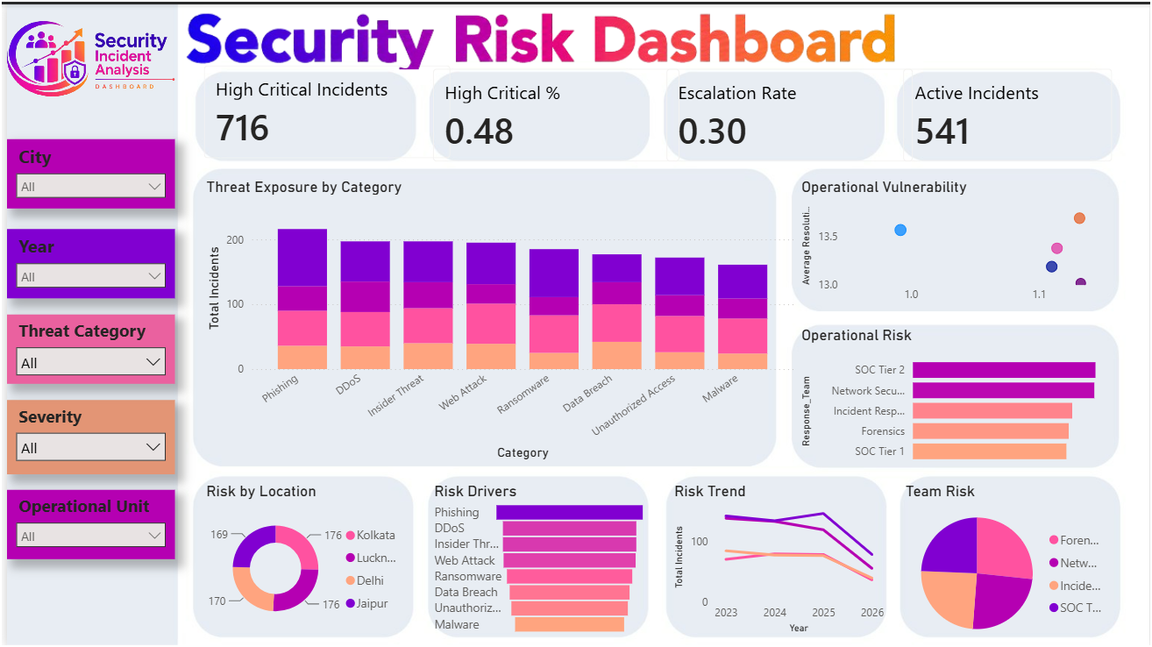
Figure 1: Security Risk Dashboard — Power BI
Filtered by City, Year, Threat Category, Severity, and Operational Unit, this dashboard combines a Threat Exposure by Category stacked bar chart with an Operational Vulnerability scatter plot and an Operational Risk ranking by response team. The lower band adds a Risk by Location donut, a Risk Drivers ranking, a Risk Trend line from 2023–2026, and a Team Risk pie chart.

2b. Predictive Intelligence Dashboard
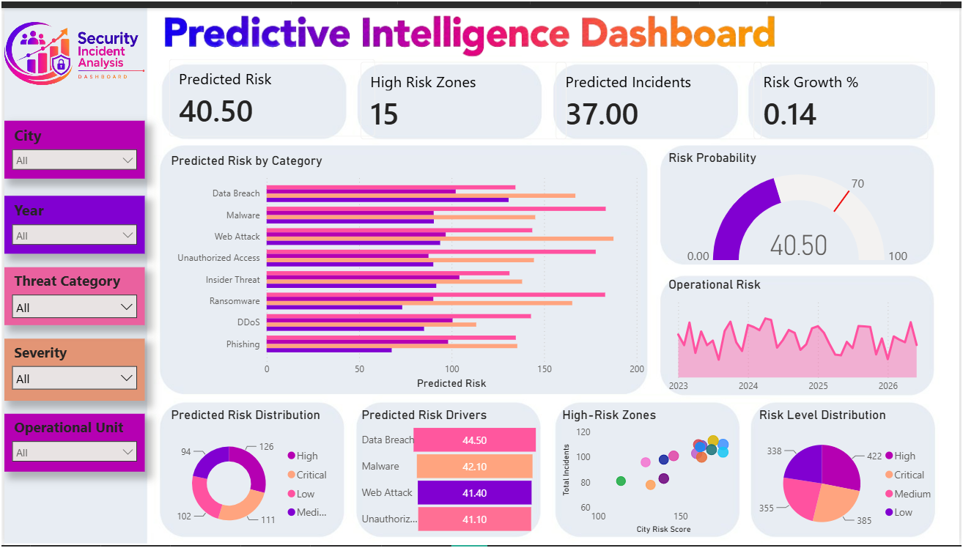
Figure 2: Predictive Intelligence Dashboard — Power BI
Using the same filter set, this dashboard forecasts risk through a Predicted Risk by Category bar chart and a Risk Probability gauge, alongside an Operational Risk trend line. The lower band shows a Predicted Risk Distribution donut, a Predicted Risk Drivers ranking, a High-Risk Zones scatter plot of City Risk Score versus incident volume, and a Risk Level Distribution pie chart.

2c. Executive Intelligence Dashboard
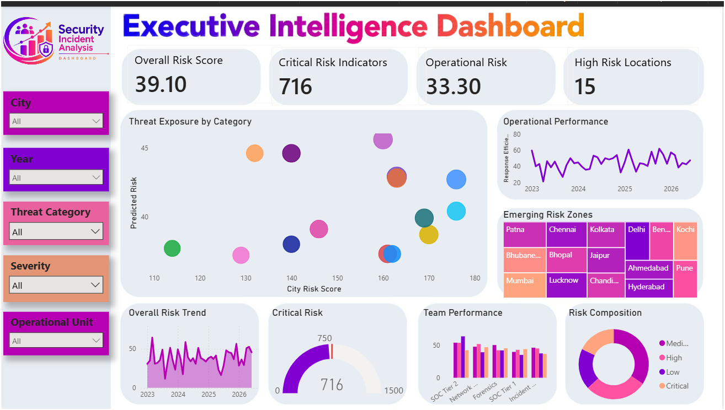
Figure 3: Executive Intelligence Dashboard — Power BI
This leadership-facing view pairs a Threat Exposure by Category scatter (City Risk Score versus Predicted Risk) with an Operational Performance trend line and an Emerging Risk Zones matrix listing the highest-risk cities. The lower band adds an Overall Risk Trend line, a Critical Risk gauge, a Team Performance bar chart, and a Risk Composition donut.
3. Three Key Insights
- Insight 1 — Forward-looking risk is led by different categories than historical volume. Where Phishing has consistently been the highest-volume category in Milestones 1 and 3, the Predictive Intelligence Dashboard's Predicted Risk Drivers ranks Data Breach (44.50) and Malware (42.10) as the top forecasted risks, ahead of Web Attack (41.40) and Unauthorized Access (41.10). This gap between historical frequency and predicted severity means the categories generating the most tickets today are not necessarily the ones that will drive the most damage going forward.
- Insight 2 — Overall risk is trending down even though incident and critical counts remain high. The Security Risk Dashboard's Risk Trend line declines from 2023 through 2026 across all response teams, and the Executive dashboard's Overall Risk Score (39.10) sits below the Predicted Risk figure (40.50). Yet 716 High Critical Incidents, an Escalation Rate of 0.30, and a Critical Risk reading of 716 out of a 1,500 scale show the absolute caseload is still substantial — the direction is improving, but the base level of risk has not yet fallen to a comfortable range.
- Insight 3 — Geographic risk has broadened from a handful of hotspots to a full watchlist of fifteen cities. Milestone 2 identified Kolkata, Delhi, Jaipur, and Lucknow as the primary high-risk cities. The Executive Intelligence Dashboard's Emerging Risk Zones matrix now tracks fifteen cities — including Patna, Chennai, Bengaluru, Kochi, Bhubaneswar, Bhopal, Ahmedabad, Pune, Mumbai, Chandigarh, and Hyderabad alongside the original four — matching the High Risk Zones KPI of 15. Risk exposure has become a nationwide monitoring problem rather than a localized one.
4. Two Business Recommendations
1. Rebalance security investment toward Data Breach and Malware defenses ahead of demand. Since predictive analytics now rank these two categories as the highest-severity forward risk — ahead of the historically dominant Phishing — budget and control upgrades (data-loss prevention, endpoint protection) should be increased proactively rather than waiting for incident volume in these categories to catch up with their predicted severity.
2. Stand up a rotating regional coverage model across all fifteen flagged high-risk zones. With emerging risk now spread across cities in nearly every region rather than concentrated in four hotspots, a single centralized response model will not scale. Establishing regional response leads for clusters of the fifteen flagged cities, prioritized by City Risk Score from the High-Risk Zones scatter, would keep response times low as the geographic footprint of risk continues to expand.

